“What do you mean you’re not global?”
LEADERSHIP DEVELOPMENT ACROSS BORDERS E. Michelle Mickens

Executive Summary

The pressure is on. The demand is high. The need is great. Where are the global leaders in your industry? An appeal for global leadership is accelerating at a pace that exceeds the ability to produce qualified leaders who can meet the demand. As it is, leaders are challenged with on-going volatility, uncertainty, complexity and ambiguity (VUCA) within their organizations. Almost daily leaders are forced to re-examine their processes and question their competencies that keeps them relevant and able to compete.
The external environmental competing forces drive organizations to globalization eliminating the option to opt-out or risk the threat of extinction. The small–mid-size enterprises (SME) are finding themselves scurrying to get in the game and stay in the game. Are you in the game? Are your leaders globally fit to cross the borders and compete internationally? Small-midsize enterprises (SME)’s must come aboard as well. To successfully go global, SMEs must be driven and have desire. Becoming global enterprise is a mindset. This paper will address what a global mindset entails. SMEs must be strategic thinkers especially when considering to become global participants. Strategic thinking helps to clarify an organization’s capabilities, priorities and identify key strategic drivers.
Over ninety-five percent of all businesses are small, including many family businesses, which generate sixty to ninety percent of new jobs annually depending on the country. This means there are tremendous opportunities for SME’s to go global particularly if they desire to grow, however, adding a global dimension to one’s business, particularly to an SME, should be contextual according to the vision, direction, and purpose of that organization. SMEs are often guilty of not being strategic planners which can be a pitfall for SMEs and in the competitive global arena, there’s little room for underperforming due to insufficient planning. An expert third party consulting firm can guide your organization to becoming global through a comprehensive strategic planning process.

The issue faced by global corporations is bridging the global divide between local and cross-cultural boundaries. One grave mistake managers make is the assumption that professional leaders in an organization who excel in their technical fields, will continue to excel if shipped abroad. This paper will offer a better process in preparing leaders to go globally.

The good news is if you are not global today, now is the perfect time to shift into gear and incorporate the competitive advantage a global enterprise offers.

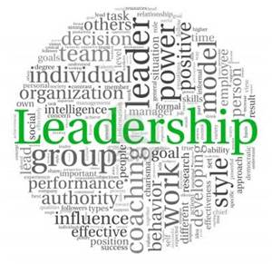

Table of Contents

Executive Summary 2
Introduction 5
Historical Strategies to Leadership Development 6
Advancements in Leadership Development Processes 8
Conclusions 11
References 12

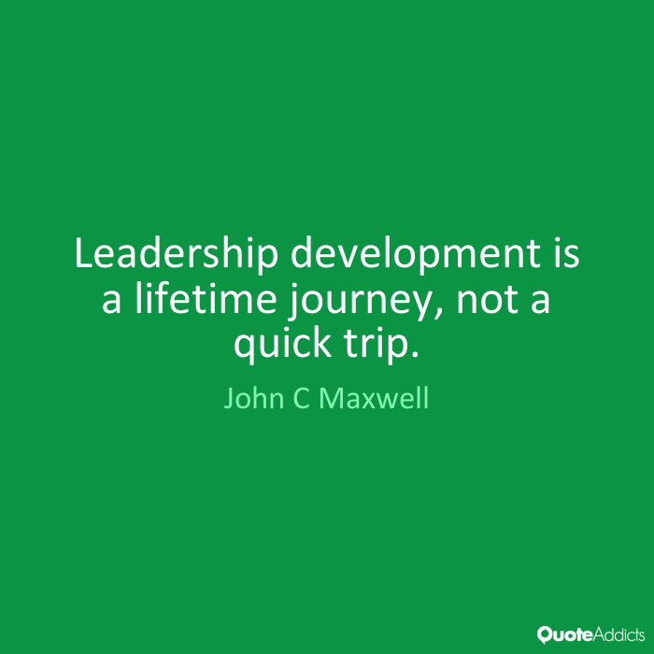

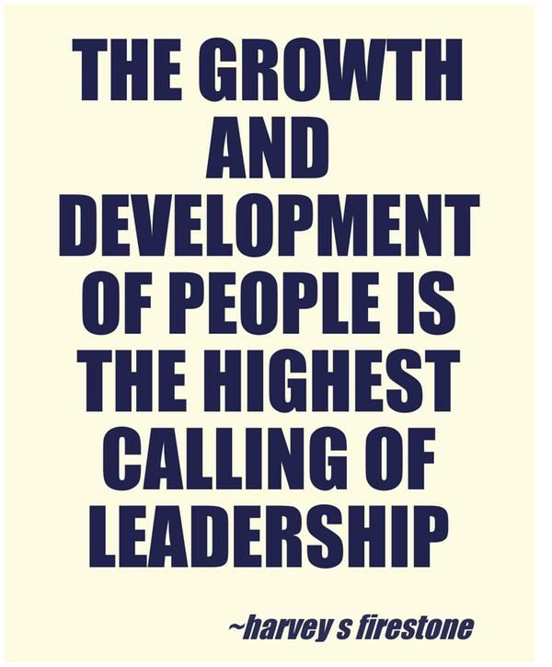

Introduction
As seen with most programs, procedures, and processes, leadership development is continuously evolving. Everything in an organization begins with the leader. Strategic leaders keep in the forefront of their minds, the vision and direction of the organization. They are sensitive to external and internal threats that may interfere with high -level performance, their relevance, and competitive advantage. Leaders also know when and how to make the changes necessary to accomplish their organization’s desired outcomes.
An effective global leader has many competencies and different levels of intelligence. Competencies that are pertinent to successful global organizations are: global mindedness, global and cultural intelligence (CQ), agility, and adaptability, to name a few. Characteristics such as:
- high emotional intelligence
- strong interpersonal abilities
- a display of ethicality
- transparency
- being visionaries
- problem-solvers
- having self-awareness
- cultural curiosity
- empathy
- collaboration and
- integration being common among global leaders
Global leaders must think and act strategically while having the skillset of aligning the appropriate leadership style that will be conducive for cross-cultural relationships. To be effective they are agile and adaptable cross-culturally. This requires arresting assumptions and stepping out of one’s comfort zone. It requires trying to learn and understand different cultural behaviors and languages.
Strategic vision and clarity about how all the pieces fit into the direction of the organization is extremely challenging. This is where an external consultant can assist. Bringing an expert consultant to help coordinate and develop a strong global leadership process can relieve you of having to stay abreast of every new development. The purpose of this report is to provide a solution to gaps in global leadership development programs. It identifies the gaps and builds a bridge.

Historical Strategies to Leadership Development
Traditionally, leadership development programs adhered to a standard that consisted of class-room training, conferences, some individual development plans involving on-line training, self-assessments and other tools. Unfortunately, these often unstructured, random and piecemeal processes, were insufficient in providing the impactful training that would effect change within an organization. If global leadership development existed, it was treated in the same manner sometimes with the option of sending a very competent local leader, to foreign territory across the borders, expected to figure out how to function successfully.
There are many empirical studies that prove leadership development programs are a bust. Even though there is a need for them, most fail to meet the demand for effective, competent, global leaders primarily due to being poorly designed.
Based on a 2014 executive global leaders survey conducted by Deliotte Consulting firm:

- Only 13 percent of companies that participated in their survey rate themselves excellent” in providing leadership programs at all levels, which includes new leaders, next-generation leaders, and senior leaders
- 66 percent believe they are “weak” in their ability to develop Millennial leaders, while only 5 percent rate themselves as “excellent”
- Over half (51 percent) have little confidence in their ability to maintain clear, consistent succession programs and
- Only 8 percent believe they have “excellent” programs to build global skills

and experiences (See figure 1 below):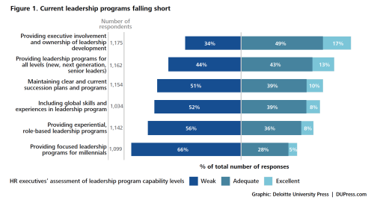

Advancements in Leadership Development Processes
Global leadership programs promote cultural agility and adaptability as previously mentioned. Part of being adaptable involves the integration of social and cultural identity. Leadership development processes must help leaders integrate their social identity with their leadership identity. A leader cannot afford to lose his or her identity nor can a leader risk not knowing how to adapt to and identify with others outside of their culture. An imbalance of social integration heightens the risk of the becoming self- consumed and even worse exclusionary. Western cultures tend to exhibit dominant behaviors that exclude cultural groups that are different then what is familiar to them. This type of behavior is self-serving and inconsiderate of the needs of those with less power or who do things differently. The right leadership development program will include mixed identity groups with the goal of addressing biases, stereotypes, and prejudices. These are reasons why leadership development programs cannot retain the old way of operating.
A sound leadership development program also requires blending cultural agility with cultural intelligence. An experiential learning style is an excellent tool that will advance a leadership development program. This technique will enhance the learning of cultural agility; cultural and global intelligence; and social identity integration of global leaders. Cultural intelligence provides leaders who are efficacious, the motivation and mental understanding that contributes to learning cross-cultures. Using online training tools in addition to developing relationships with peers of different cultures, develop cultural competencies.
A global leader should know when and when not to utilize cultural adaptation. An expert in this field, Caligiuri (2013) said “knowing when to adapt to a cultural norm, when to minimize or persuasively override a cultural norm, and when to integrate multiple cultural norms” reflects an effective culturally agile leader.
Leadership and executive leadership coaching is not only popular to add to a leadership development program but is one of the most cost efficient investments that adds value to leadership development programs. Empirical data proves professional coaching to give a return on investment between 340 to 700 percent. The longevity of coaching is promising. It’s almost as common as having a personal training.
In addition to being affordable, a benefit of using a professional coach is the convenience and flexibility of using a coach. Coaches can provide one-on-one training to help executives fill in development gaps or a coach can work with an entire team.
Organizations use executive coaches because of benefits in key performance areas such as:
- Productivity
- Quality
- Organizational strength
- Customer service
- Reducing customer complaints
- Retaining executives
- Cost reductions
- Bottom-line profitability

Perhaps it’s time to revamp the old leadership development program and sharpen your competitive edge.

Conclusions
There is an urgency for effective, global leaders. Is your organization global ready?
The task of designing a comprehensive leadership development program is daunting at best. Ensuring that it has the right global composition can send you over the edge. An expert consultant such as Live 4 Change LLC, can provide you with the comfort of knowing how to assess what your organization needs, and build a customized program that will position you to surpass your competition.
Live 4 Change, LLC is a consulting firm designed to bring transformational solutions to you as the leader and your organization through strategies, structure, and systems to enhance organizational performance through embracing sustainability practices. We assist businesses with leadership development training, workshops, one-on-one and group coaching as well as mentoring services. We also support small businesses by developing strategic sustainability plans.
Our motto is “Transitioning you from where you are now to where you want to be.”

E. Michelle Mickens,CEO

Live 4 Change, LLC

e.michellemickens@live4changellc.com

(419) 490-4454

References

Auerbach, J. E. (2005). Seeing the Light: What Organizations Need to Know About Executive Coaching. Executive College Press: Pismo Beach, CA.
Caligiuri, P. (2012). Cultural Agility: Building a pipeline of successful global professionals. San Francisco: Jossey-Bass.
Canwell, A., Dongrie, V., Neveras, N., & Stockton, H. (2014, March 7). Leaders at all levels: Close the gap between hype and readiness | Deloitte University Press. Retrieved from https://dupress.deloitte.com/dup-us-en/focus/human-capital-trends/2014/hc-trends-2014-leaders-at-all-levels.html
George, B. (2015). The New Global Leaders. People & Strategy, 38(3), 26-30.
How to Take Your Company Global. (2016). Entrepreneur. Retrieved from http://www.entrepreneur.com/article/159252
Hughes, R. L., Beatty, K. C., Dinwoodie, D. L., & Center for Creative Leadership. (2014). Becoming a strategic leader: Your role in your organization's enduring success (2nd ed.). San Francisco, California: Jossey-Bass.
McCauley, C. D., Van, V. E., & Center for Creative Leadership. (2010). The Center for Creative Leadership handbook of leadership development. San Francisco: Jossey-Bass.
Ng, K., Dyne, L. V., & Ang, S. (2009). Developing Global Leaders: The Role of International Experience and Cultural Intelligence. Advances in Global Leadership, 5, 225-250. doi:10.1108/S1535-1203(2009)0000005013
Nini, Y. (2012). Small Business and International Entrepreneurship in the Economic Hard Time: A Global Strategic Perspective. International Journal of Entrepreneurship, 16113-131

Hughes, R. L., Beatty, K. C., Dinwoodie, D. L., & Center for Creative Leadership. (2014). Becoming a strategic leader: Your role in your organization's enduring success (2nd ed.). San Francisco, California: Jossey-Bass.
Nini, Y. (2012). Small Business and International Entrepreneurship in the Economic Hard Time: A Global Strategic Perspective. International Journal of Entrepreneurship, 16113-131
Hughes, et al (2014).
How to Take Your Company Global. (2016). Entrepreneur. Retrieved from http://www.entrepreneur.com/article/159252
George, B. (2015). The New Global Leaders. People & Strategy, 38(3), 26-30.
Canwell, A., Dongrie, V., Neveras, N., & Stockton, H. (2014, March 7). Leaders at all levels: Close the gap between hype and readiness | Deloitte University Press. Retrieved from https://dupress.deloitte.com/dup-us-en/focus/human-capital-trends/2014/hc-trends-2014-leaders-at-all-levels.html
McCauley, C. D., Van, V. E., & Center for Creative Leadership. (2010). The Center for Creative Leadership handbook of leadership development. San Francisco: Jossey-Bass.
Ibid.
Caligiuri, P. (2012). Cultural Agility: Building a pipeline of successful global professionals. San Francisco: Jossey-Bass.
Ng, K., Dyne, L. V., & Ang, S. (2009). Developing Global Leaders: The Role of International Experience and Cultural Intelligence. Advances in Global Leadership, 5, 225-250. doi:10.1108/S1535-1203(2009)0000005013
Ibid.
Caligiuri, P. (2012).
Caligiuri, P. (2013). Developing culturally agile global business leaders. Organizational Dynamics, 42(Special Issue: Global Leadership), 175-182. doi:10.1016/j.orgdyn.2013.06.002
Auerbach, J. E. (2005). Seeing the Light: What Organizations Need to Know About Executive Coaching. Executive College Press: Pismo Beach, CA.

